Report designed using Silverlight designer, when seen in Silverlight viewer looks like this
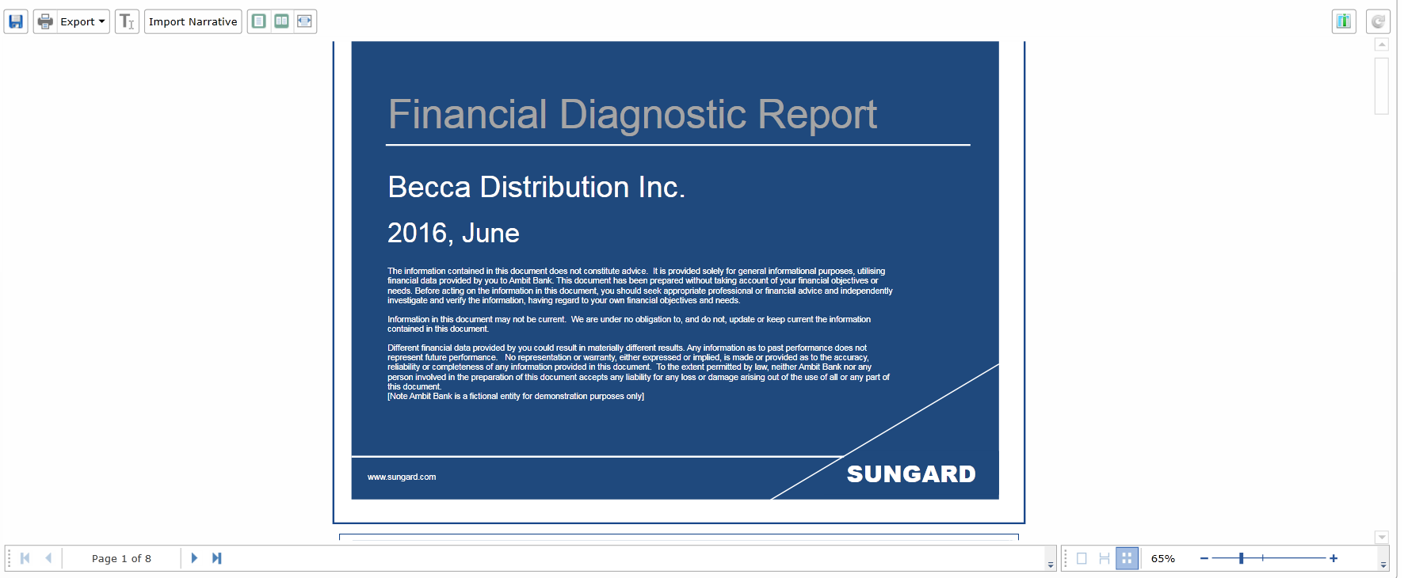
Save this report to Report.mdc file
report.SaveDocument(@"C:\Report.mdc"); // or mrt.

Open sample application @Stimulsoft Reports.Web\ASP.NET MVC\HTML\Using Viewer, Razor, Interactions\Controllers\HomeController.cs
report.LoadDocument(Server.MapPath("~/Content/Reports/Report.mrt"));

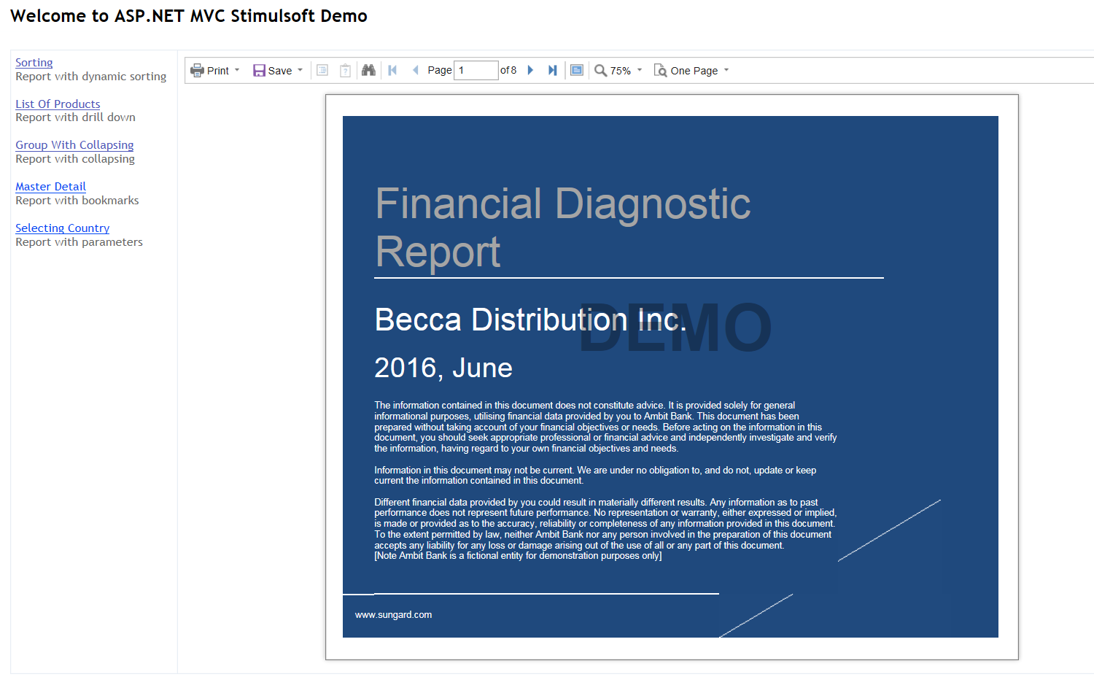

See the formatting of text on header is changed.
Formatting at bottom where SUNGARD was displayed in 1st screenshot is not visible in 2nd screenshot

