StiMvcMobileDesigner: load byte[], then click Preview
( See highlighted in Red)

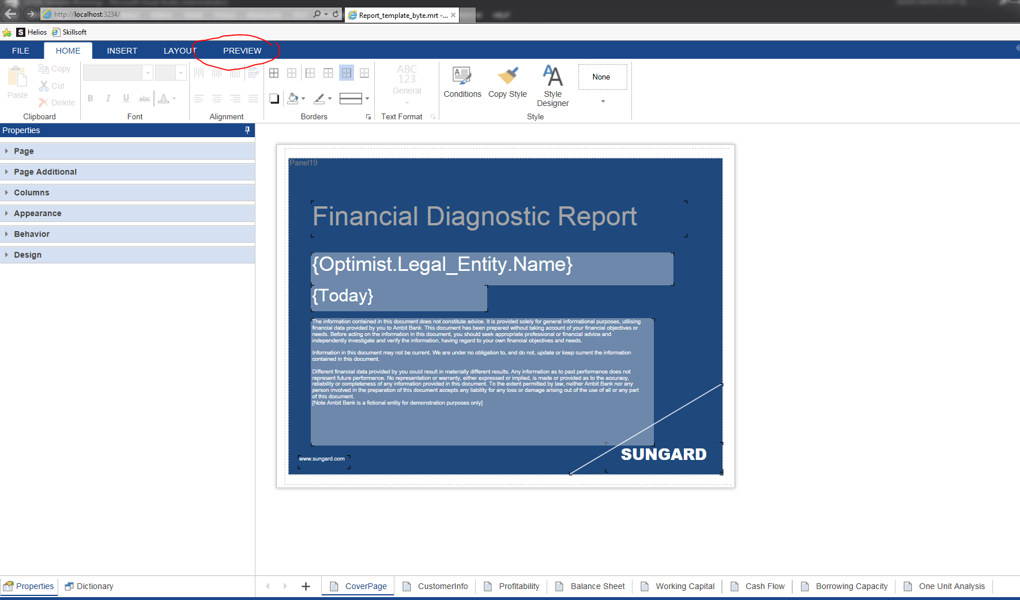

Click Preview( See highlighted in Red)


