- On clicking Print dropdown, it displays its option at the end of the page as shown below:
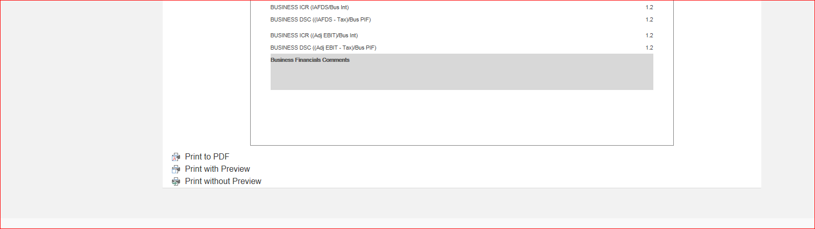

- On clicking Save dropdown, it displays the options at the end of the page shown below:
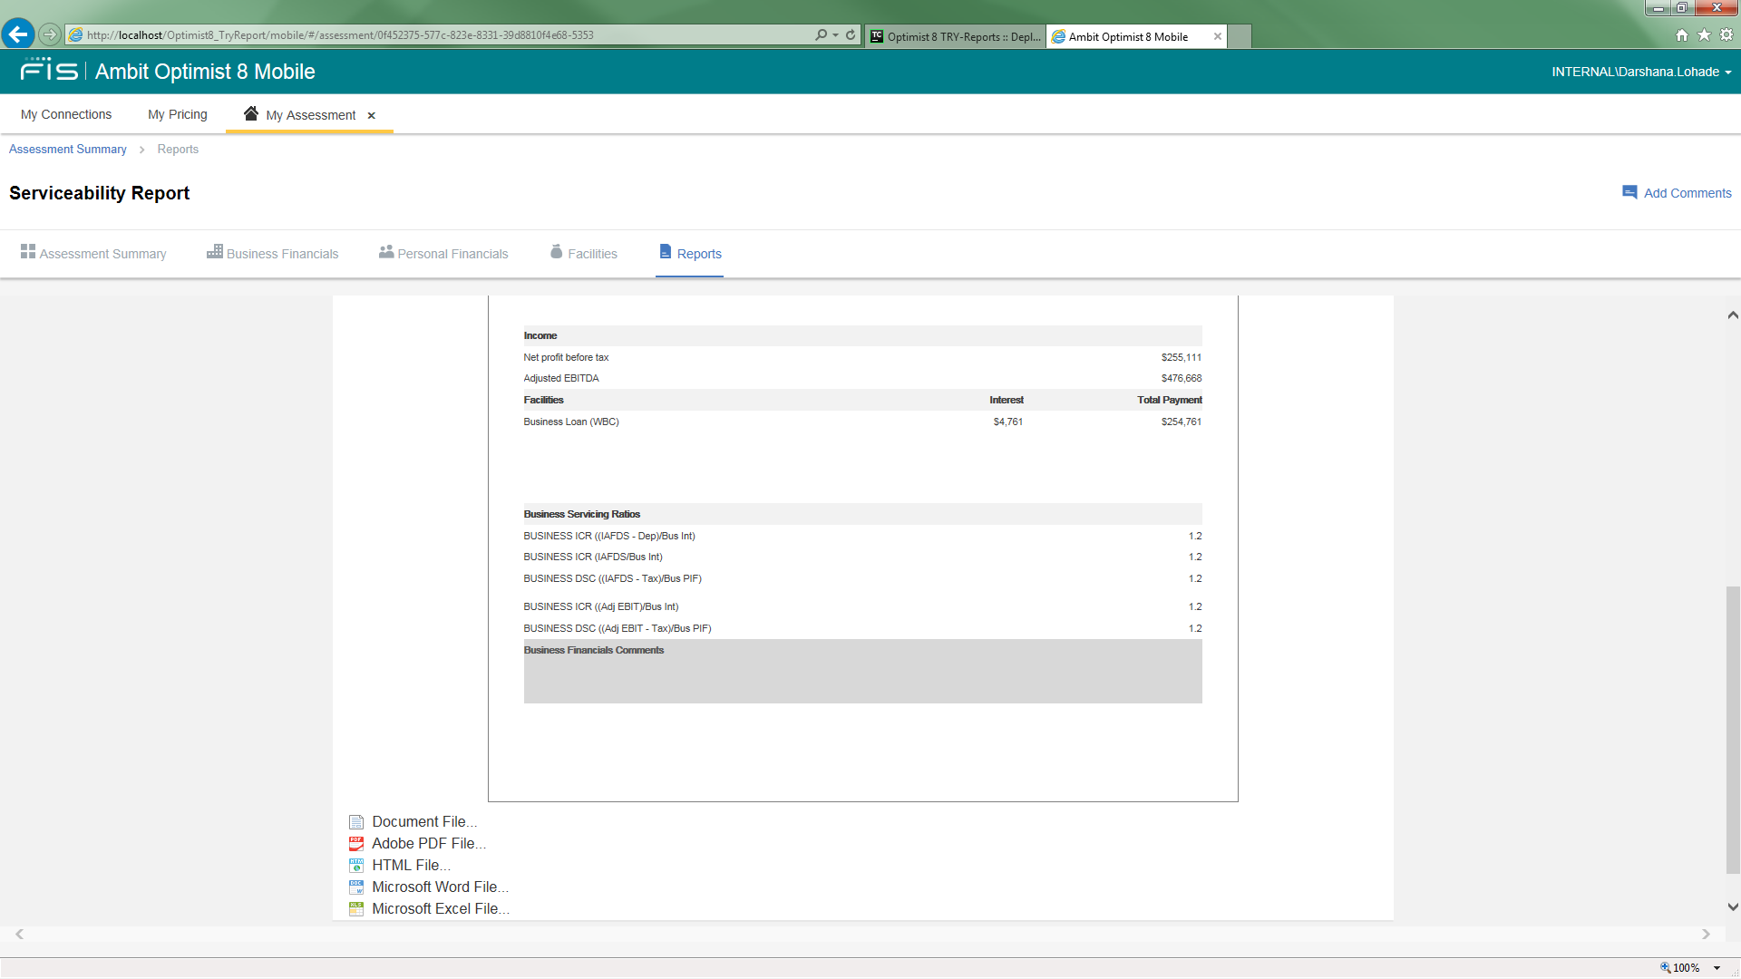

- Similarly for One Page/Whole Page dropdown:
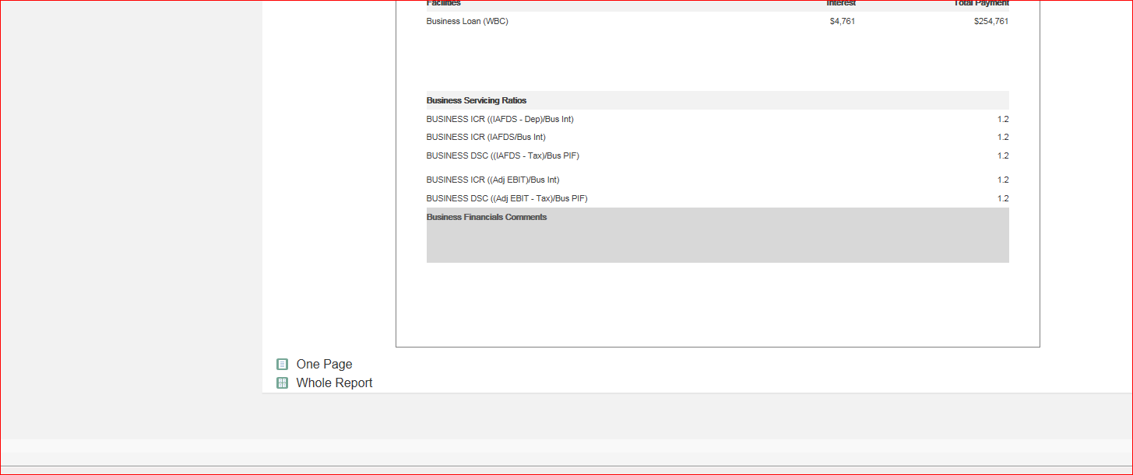

- On clicking Zoom:


