EDAX APEX |  |  |  |  |  |  |  |  |  |  |  |  |  | 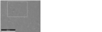 |  |  |  | Page | 1
Author: |  |  |  |  |  |  | Apex User
Creation: |  |  |  |  |  |  | 2016-08-23T16:55:17.98+05:30
Sample Name: |  |  |  |  |  |  | New Sample
 |  | 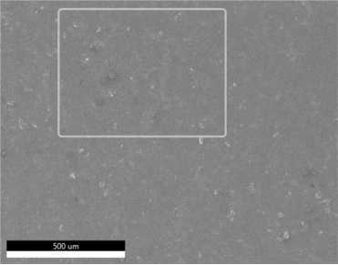 |  |  |  |  |  |  | Image
 |  | 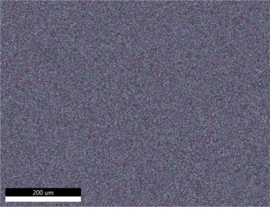 |  |  |  |  |  |  | 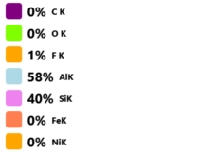
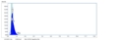 |  |  |  |  |  |  |  |  |  |  |  |  |  |  |  | 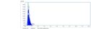
EDAX APEX |  |  |  |  |  |  |  |  |  |  |  |  |  |  |  |  |  | Page | 2
 |  | 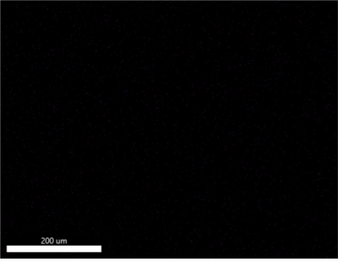 |  |  |  |  |  |  | C K_ROI (2)
 |  |  |  |  |  |  |  |  |  | 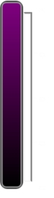
 |  | 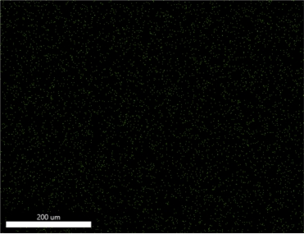 |  |  |  |  |  |  | O K_ROI (2)
 |  |  |  |  |  |  |  |  |  | 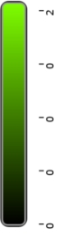
 |  | 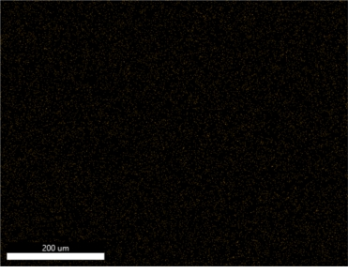 |  |  |  |  |  |  | F K_ROI (4)
 |  |  |  |  |  |  |  |  |  | 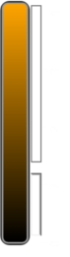
 |  |  |  |  |  |  |  |  |  |  |  |  |  |  |  |  | 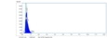
EDAX APEX |  |  |  |  |  |  |  |  |  |  |  |  |  |  |  |  |  | Page | 3
 |  | 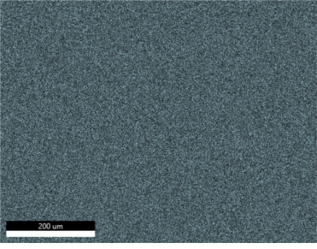 |  |  |  |  |  |  | AlK_ROI (21)
 |  |  |  |  |  |  |  |  |  | 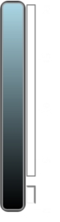
 |  | 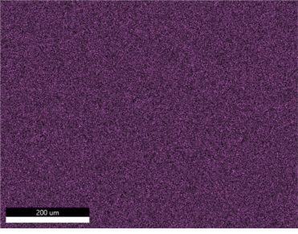 |  |  |  |  |  |  | SiK_ROI (17)
 |  |  |  |  |  |  |  |  |  | 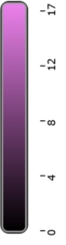
 |  | 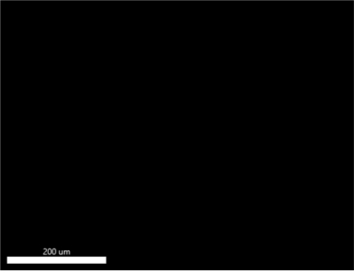 |  |  |  |  |  |  | FeK_ROI (0)
 |  |  |  |  |  |  |  |  |  | 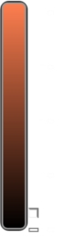
EDAX APEX |  |  |  |  |  |  |  |  |  |  |  |  |  |  |  |  |  | Page | 4
 |  |  |  |  |  |  |  |  | NiK_ROI (0)
 |  |  |  |  |  |  |  |  |  | 

