Desired outcome

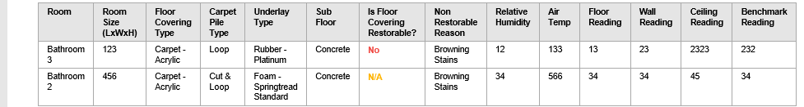

Actual Outcome
That too columns are not ordered and duplicate headers.
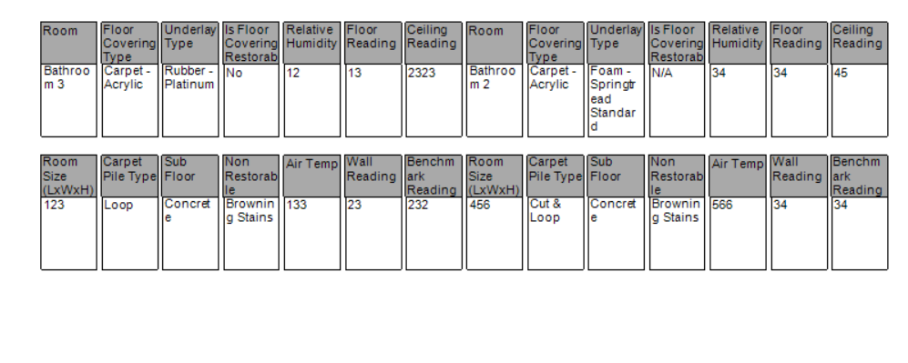

Sharing the result set I have as well in a separate excel sheet

