Stimulsoft Thai character issue

Stimulsoft version: 2023.1.6.0
We have loaded the required .ttf file as recommended by Stimulsoft.

Steps followed to replicate the issue
- Launch the application
- Zoom the report to see clearly, please refer below screen shot1

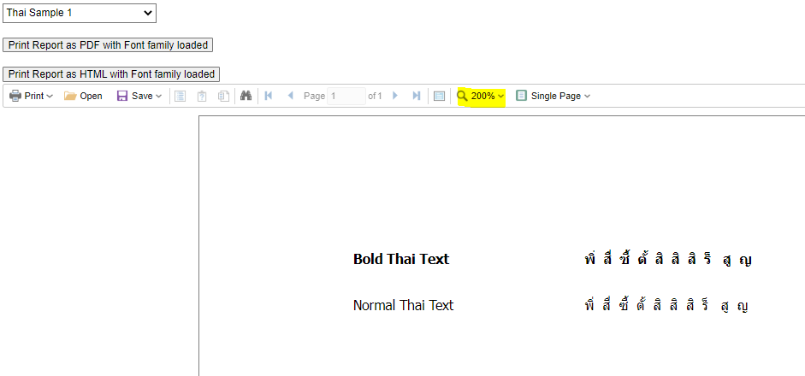
Screen shot1

- Click on the “Print Report as PDF with Font family loaded” or “Print -> PDF” button, report pdf with be opened. Please refer Screen shot 2 and Screen Shot 3. Zoom in to see clearly

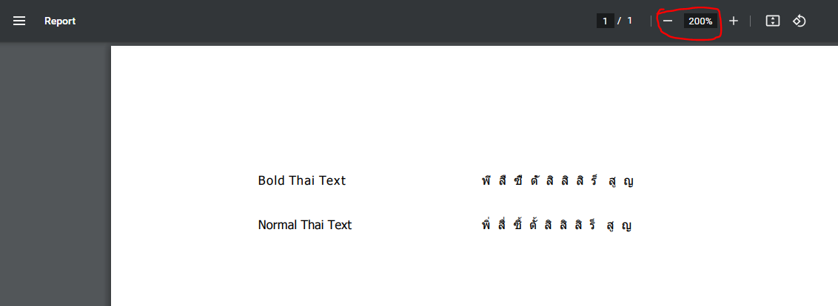
Screen Shot 2 (on clicking: Print Report as PDF with Font family loaded button)

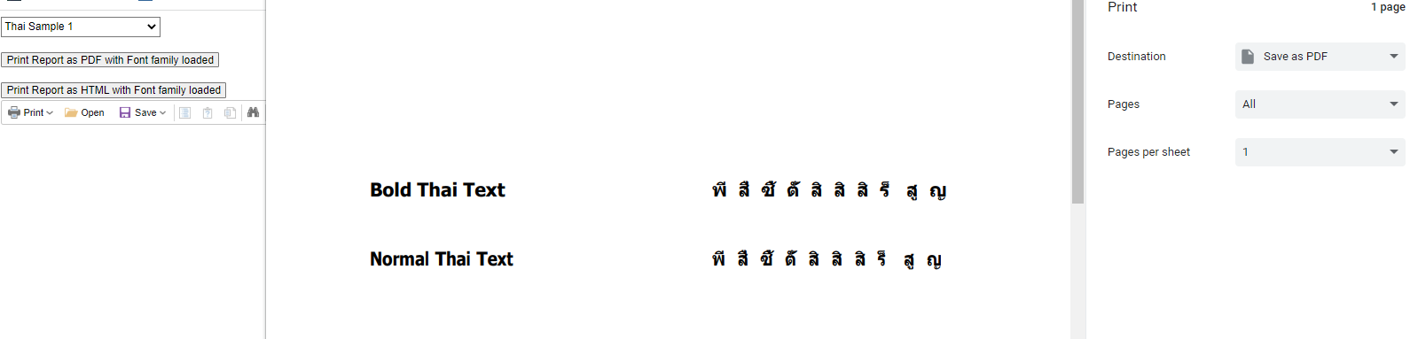
Screen Shot 3 (on clicking: Print -> PDF button)

- If you observe in “Screen Shot 1” and “Screen Shot 2”/ “Screen Shot 3” you could notice that some of the text is not getting rendered in PDF which is visible on report rendered on UI.
- Please refer below Screen Shots where we have highlighted the text which is missing in PDF when compared with report rendered on UI.

Screen shot report from PDF using “Print->PDF”:
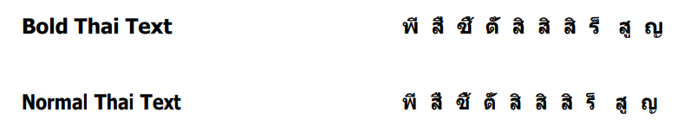

Screen shot from PDF using “Print Report as PDF with Font family loaded” button. Here you can notice the same text which is set to Bold is not rendered properly. Highlighted text is missing with compared with Normal text.
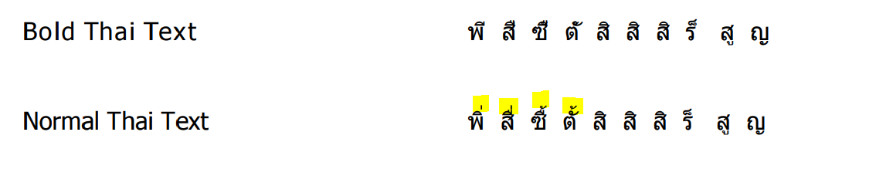

Screen shot report from UI:


