Manually Entered Data Source:
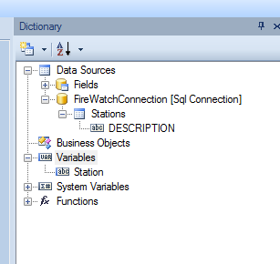

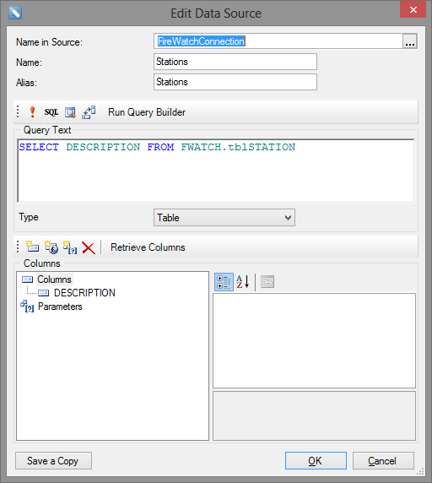
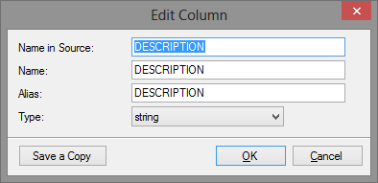
End Data Bound Filter
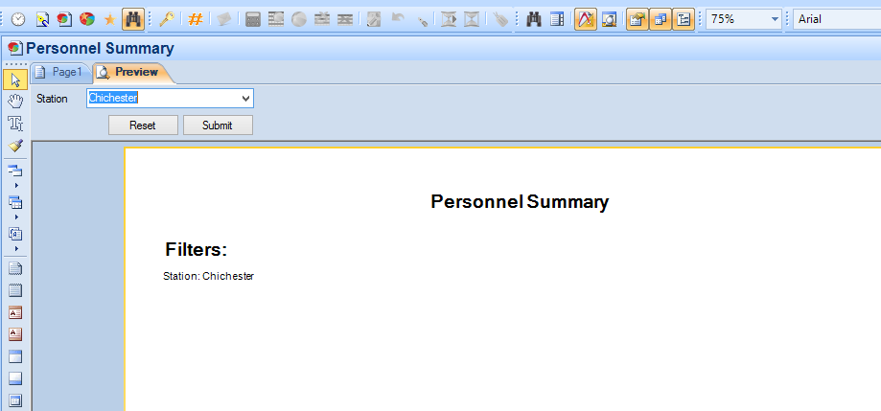
XML
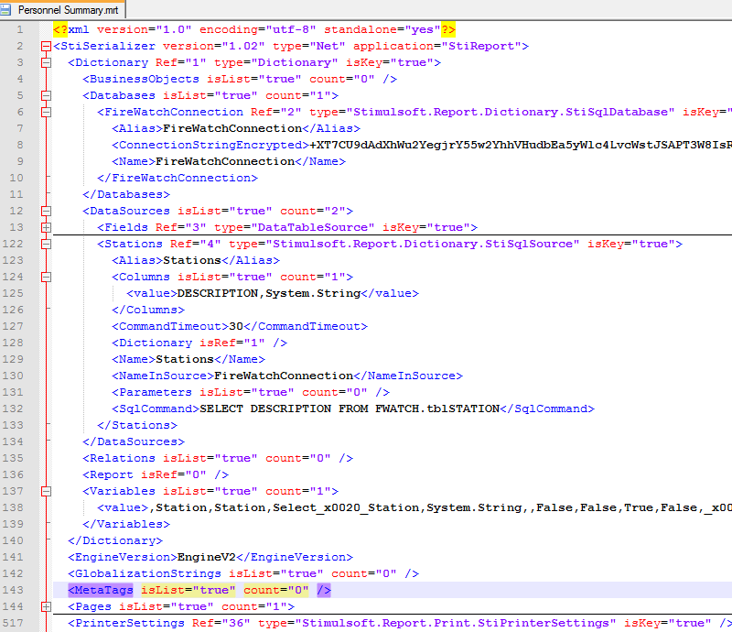

FireWatch Steps to binding values:
- User update report.
- All previous filters removed.
- Report Variables are created for each filter.
  - If prompt exists for filter -- > FireWatch Connection checked to see if it exists.
    - Creates connection if it does not exist
    - Leaves connection if it does exist
- For each filter “type” a new data source is created.
  - Select statements inserted into data source including the column being selected from.
- For each filter a new variable is created
  - Set up Variable
  - Data bind prompt values to new data sources
  - None prompt values = normal set up
How to structure

