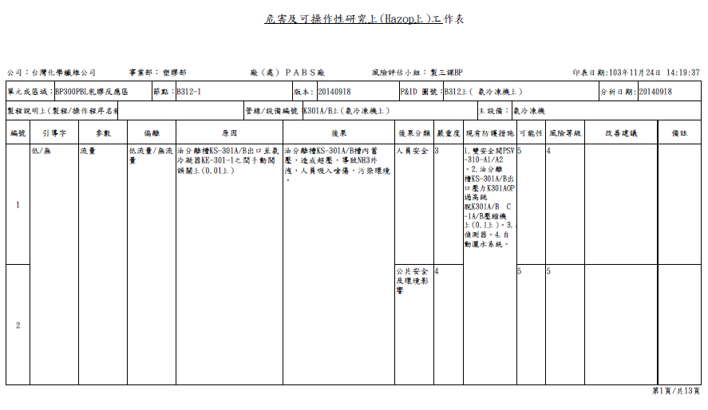
If no waste space,row 1~row4 can present in one page
processing Duplicates→Global Merge
Waste space

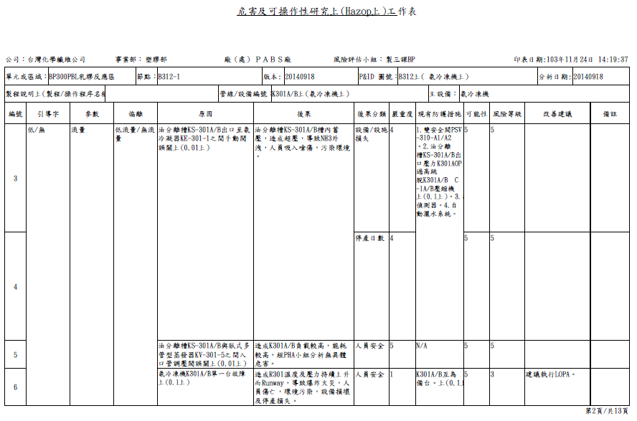
Waste space

