Opening the attached sample report
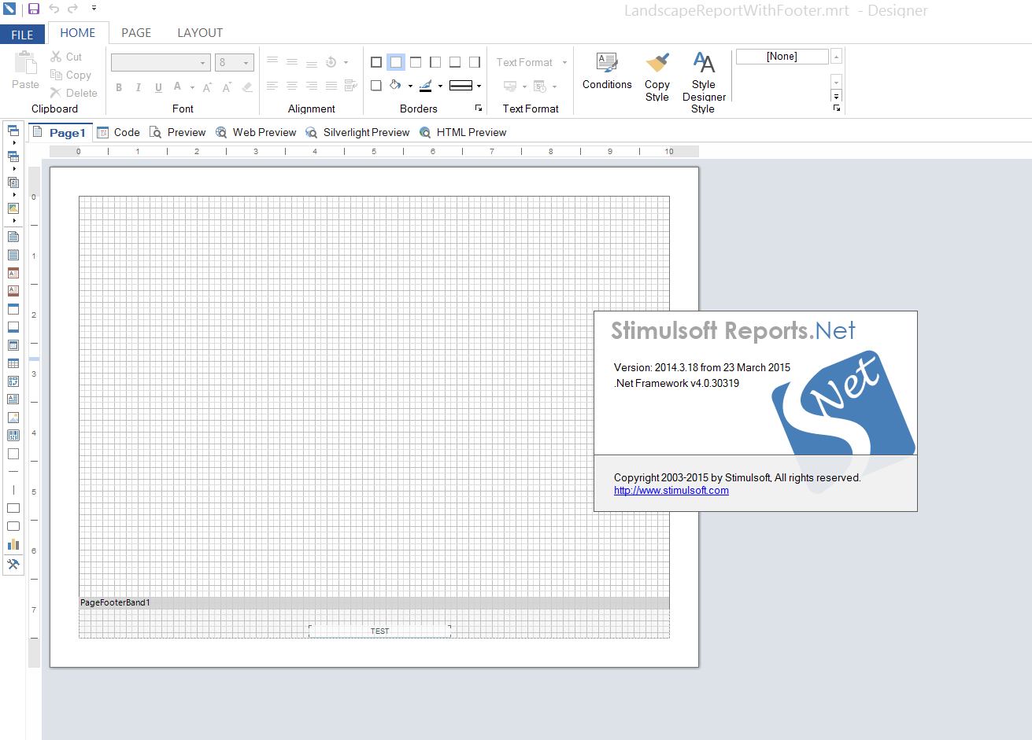

Using the Web Preview to print the report: 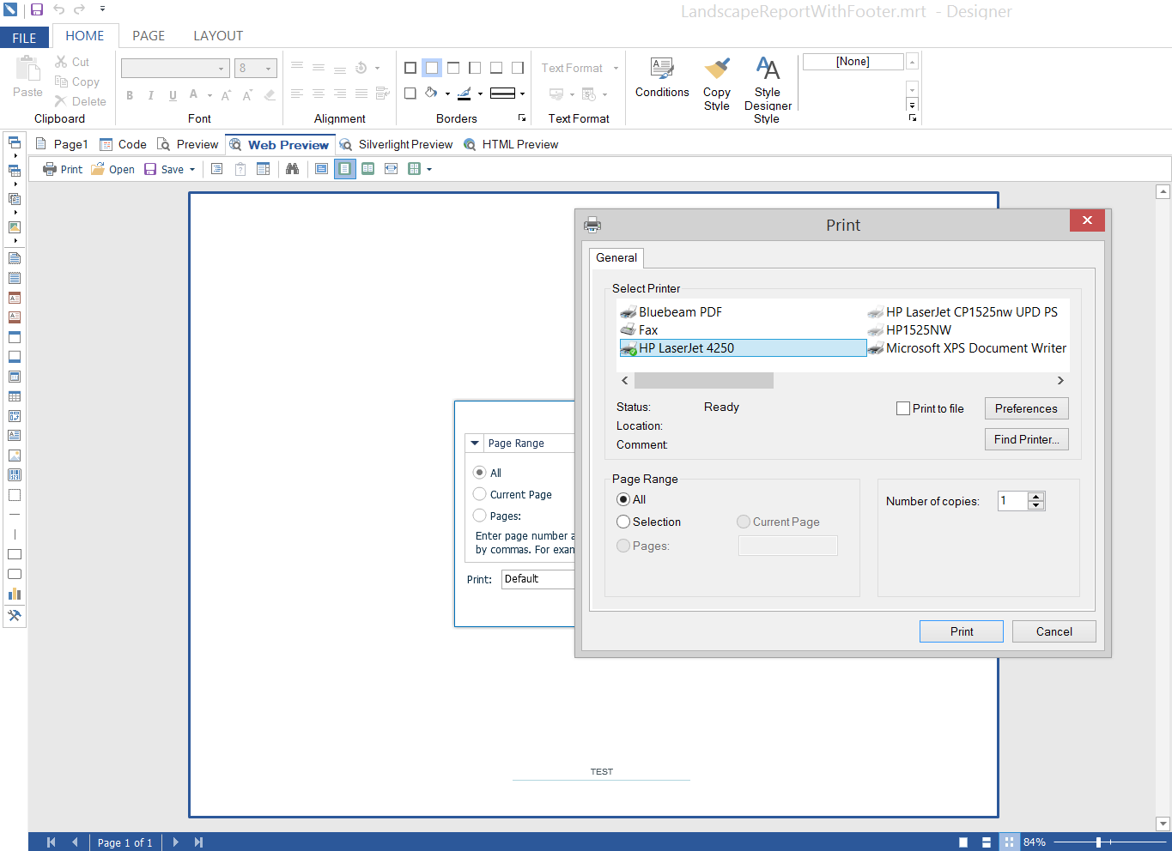

Correct output (footer at bottom of page)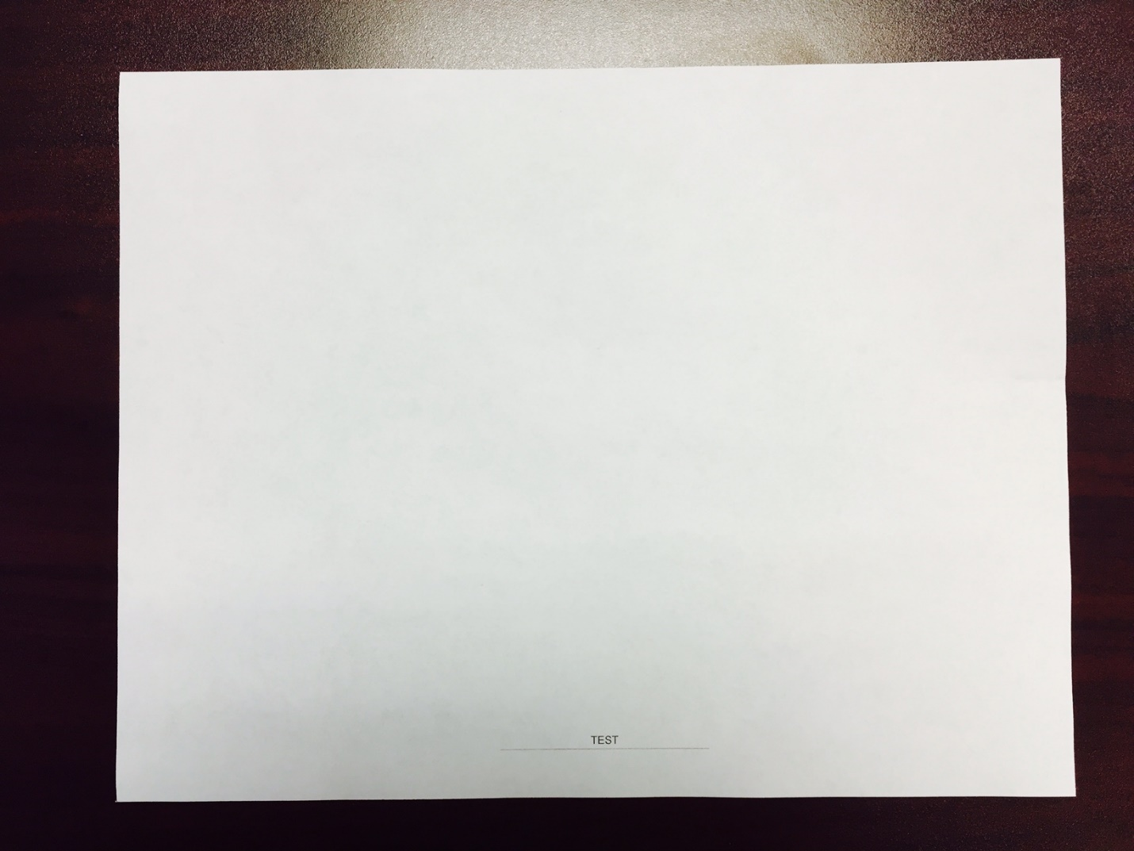

Using the Silverlight Preview on the same report and printing to the same printer: 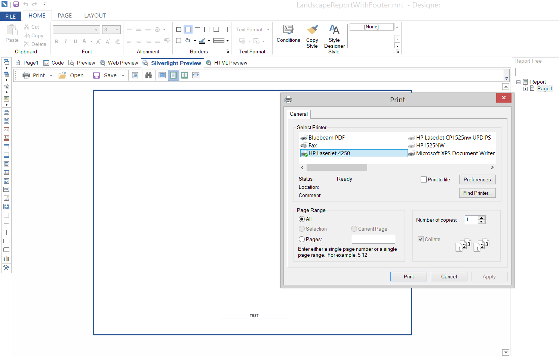

Blank page, no footer (because it is getting clipped off).

