Stimulsoft subreport inside the mrt file format while reviewing
Text editor is Wysiwig
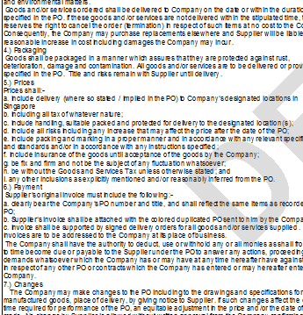
The same after print pdf/ printed as a hard copy


